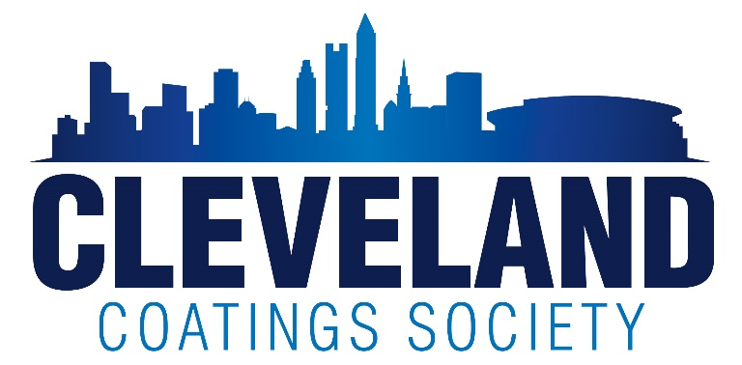
Scholarship/Continuing Education Application
Application deadline is March 15, 2024
All applications will be judged in several categories, in comparison with other applications, by the Board of Directors of the Cleveland Coatings Society, all decisions are final.
SCHOLARSHIP APPLICATION:
___4 Year High School Senior
___1 Year Continuing Education (CCS Members or Members children)

Personal Information:
Applicants Name:
Complete Address:
Phone: Email Address: Age:
Name of Parent (CCS Member):
Name of Company where CCS Parent is Employed:
Member Parents email address:

Work Experience/Internships (of none, so indicate):
Name of Company: Type of work:
Dates of employment: Reason for leaving:

Name of Company: Type of work:
Dates of employment: Reason for leaving:

Name of Company: Type of work:
Dates of employment: Reason for leaving:

Academic:
Name of Current High Scholl/College Enrolled:
Complete School Address:
Year Graduating/Graduated:
Guidance Counselor: Phone:
Intended College Major:
Name & Location of College/University which you plan to attend:

Starting Date:

List Math & Science classes completed: (include levels i.e. Advanced Placement, etc. & attach extra sheets if necessary)

List Awards/Special Recognition:

List Activities (School & Community):

Paper & Test Scores:
SAT or ACT Test scores (4 Yr Scholarship only)
Copy of school transcript
Accumulative Grade Point Average (through last semester):___________
Class Standing (check one) Upper 1/3______ Middle 1/3______ Lower 1/3_______

4 Year Applicant Requirements (Not required for Continuing Education application)

1. Letters of Recommendation:
- Minimum 2 letters total from any of the following sources:
a. Education (teacher, counselor or administrator)
b. Business (supervisor)
c. Personal (friend or relative)
d. Athletic coach or supervisor
2. Essay consisting of 200-500 words (attach separate sheet):
- Subject matter may include topics such as:
- How would you choose/or why have you chosen your career?
- What do you hope to do with your degree?
- What are other life goals outside of your education?
- Describe different paint systems used in the coating industry, give the pros and cons of each system and explain where used in the industry (cite references, if applicable)
- Topic of your choice

1 Year Continuing Education Requirements (Not required for 4 Year Scholarship applications)
- Letter stating your goals and the field of study the funds will be used for.
- Copy of school transcript when currently attending school.

I hereby certify that all statements on this application are true:

Student Signature______________________ Date_______________

Parents Signature_______________________ Date_______________

Complete this application, either typed or handwritten, include your current transcript and ACT/SAT scores, 200-500 word essay, letters of recommendation, and all other additional documentation.

Scan and email all documents to Barbara Varone: varone@kowa.com

Additional contact information can be found at https://clevelandcoatingssociety.org/scholarships/

