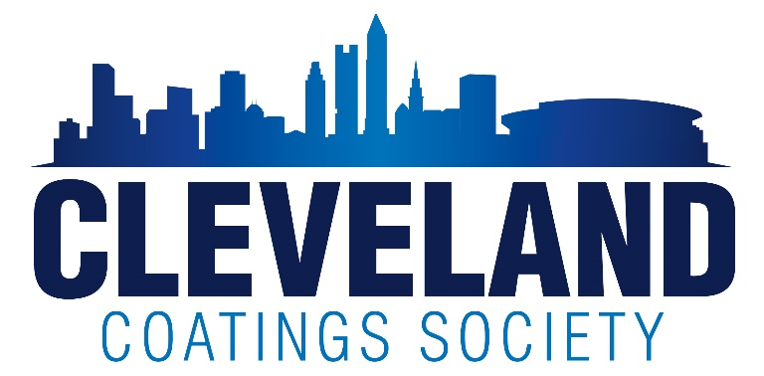

CLEVELAND COATINGS SOCIETY
Education Scholarship Guidelines

Potential Award Amounts:
Awards are dispersed based on the funds available as a result of multiple fundraisers held during the previous year. The amount dispersed varies per year and no amount is guaranteed.

• 4 Year Scholarship—High School Senior accepted to college
-Annual amount of $1000 per year awarded for 4 years

• 1 Year Scholarship---Continuing Education
-Amount varies based on funds available, and is usually limited to $1000 per year.

4 Year Scholarship Eligibility:
- Child of an active CCS member in good standing. Member should attend a minimum of 4 meetings or events in all years that the scholarship is received.
- Applicant must be a senior in high school planning to attend an institution of higher learning during the ensuing fall term.
- Preference given to those students majoring in a science.

1 Year Continuing Education Scholarship Eligibility:
- CCS members in good standing taking career related classes.
- Child of an active CCS member in good standing. Member should attend a minimum of 4 meetings or events in all years that the scholarship is received.
- All applicants must be planning to attend an institution of higher learning during the ensuing fall term.
- Preference given to those students majoring in a science.
- Continuing Education applicants cannot be a current CCS 4 Year Scholarship winner.
- Award winners may apply yearly, up to a maximum of 4 yearly awards.

4 Year Scholarship Application Requirements: (See the application for complete details.)
- Applications submitted must be completed with all requirements.
- The application can be typed, hand written, or prepared in MS word.
- High School transcripts including: Accumulative grade point average and class standing
- ACT or SAT Scores
- Letters of recommendation from any of the recommended sources listed on the application.
- Essay consisting of 200-500 words. Subject matter may include any of the recommended topics.

1 Year Continuing Education Application Requirements: (See the application for complete details.)
- Applications submitted must be completed with all requirements.
- The application can be typed, hand written, or prepared in MS word.
- School transcript if currently enrolled in school.
- Letter stating your goals and the field of study the funds will be used for.

All applications will be judged in several categories, in comparison with other applications, by the Board of Directors of the Cleveland Coatings Society. All decisions are final.

Yearly Continuation of the 4 Year Scholarship:
- Continuity of award depends on the financial stability of the Society. The CCS reserves the right to decrease or withdraw Scholarship monies due to insufficient funds.
- Four Year Scholarship recipients must annually submit proof of GPA (3.0 minimum) and major to continue receiving the scholarship award in sophomore, junior and senior years.
- Parent must be a member in good standing and continue to attend meetings and events (minimum of 4 per yr). The award will be discontinued due to inactivity of a parent member.

Yearly Payment Request Process:
- Submit the request prior to the tuition due date. Penalties due to late submissions are not the responsibility of CCS.
- Include a complete transcript showing a 3.0 grade point average.
- Provide a copy of the tuition bill that includes the required information including the bursars address and the student account number.
- Students who are required to complete internships may spread the 4 yearly payments over 5 years.

Send all payment requests and questions via email to Barbara Varone varone@kowa.com

