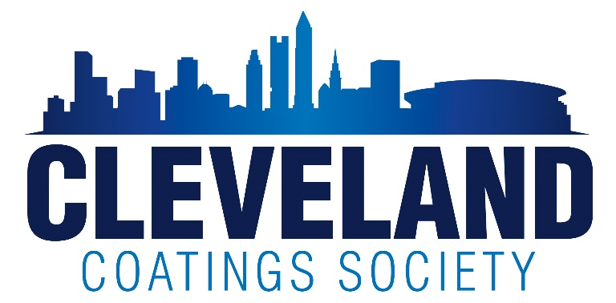

Dear Scholarship Awardees,

The Cleveland Coatings Society Education Committee again congratulates you for been selected as a recipient of a Scholarship Award. This letter explains to you the requirements for requesting a tuition payment.

Scholarships awarded the first year are paid when you receive your first tuition bill. In order to accept and process a tuition payment, most universities require us to provide the student’s complete name, current address, and account or student ID number with payment. Please make sure that you provide this information, along with the correct university bursars mailing address to ensure proper processing of scholarship payments.

Scholarships received for multiple year scholarships require additional information. It is important for us to advise you that the continuation of this scholarship is dependent upon maintaining your grades and that your parents remain active in the society. The annual requirements are listed below.

- Student annually submits proof of a minimum 3.0 GPA and major to continue scholarship award in Sophomore, Junior and Senior years
- Parent of student continues as a CCS member in good standing current membership and attend 4 events each year. Due to covid restrictions, this may change as we move forward.
- Students that receive a 4 year award, but are in a 5 year program due to internships and/or Co-ops, can request 4 payments over 5 years.

Once again, congratulations on your accomplishments and best wishes to you in your continued studies in college!

Please send the required information or any questions via e-mail to our scholarship chair, Barb Varone, at varone@kowa.com

Sincerely,

Barbara Varone
Scholarship Chair

